Q1) Identify the Data type for the Following:

Activity | Data Type
Number of beatings from Wife | Discrete Data
Results of rolling a dice | Discrete Data
Weight of a person | Continues Data
Weight of Gold | Continues Data
Distance between two places | Continues Data
Length of a leaf | Continues Data
Dog's weight | Continues Data
Blue Color | Discrete Data
Number of kids | Discrete Data
Number of tickets in Indian railways | Discrete Data
Number of times married | Discrete Data
Gender (Male or Female) | Discrete Data

Q2) Identify the Data types, which were among the following
Nominal, Ordinal, Interval, Ratio.
Data | Data Type
Gender | Discrete data- Nominal
High School Class Ranking | Discrete data- Nominal
Celsius Temperature | Continuous- Interval
Weight | Continuous- Ratio
Hair Color | Discrete data- Ratio
Socioeconomic Status | Continuous- Interval
Fahrenheit Temperature | Continuous – Ratio
Height | Continuous- Ratio
Type of living accommodation | Discrete- Ordinal
Level of Agreement | Discrete- Interval
IQ(Intelligence Scale) | Discrete- Interval
Sales Figures | Discrete- Interval
Blood Group | Discrete- Ratio
Time Of Day | Continuous – Interval
Time on a Clock with Hands | Continuous- Interval
Number of Children | Discrete- Interval
Religious Preference | Discrete- Ratio
Barometer Pressure | Continuous – Interval
SAT Scores | Continuous- Ratio
Years of Education | Discrete- Nominal

Q3) Three Coins are tossed, find the probability that two heads and one tail are obtained?
Ans: When 3 coins are tossed, their will be 8 possible outcomes.
Let ‘S’ be the Sample Space
S = {HHH, HHT, HTH, THH, TTT, TTH, THT, HTT}
Let ‘A’ be the event of getting two heads and one tail by tossing 3 coins
Therefore, Number of Favorable outcomes = 3
Total number of Possible outcomes = 8
P(A) = Number of Favorable outcomes / Total number of Possible outcomes
3/8 = 0.375
So that, the Probability of getting 2 Heads and 1 Tail is 0.375

Q4) Two Dice are rolled, find the probability that sum is
- Equal to 1
- Less than or equal to 4
- Sum is divisible by 2 and 3
Ans: When two dice are rolled, The possible outcomes is 6*6 = 36
- There will be no possible outcomes which is equal to 1,
P(A) = Number of Favorable outcomes / Total number of Possible outcomes
= 0/36 = 0
Therefore, Probability of getting outcome which is Equal to 1 is 0.
- There will be 6 possible outcomes of getting less than or equal to 4
i.e., S = {(1,1) (1,2) (1,3) (2,1) (2,2) (3,1)}
P(A) = 6/36
= 1/6
= 0.16
Therefore, Probability of getting outcome which is Less than or equal to 4 is 1/6 or 0.16

- There will be 6 possible outcomes of getting the Sum which is divisible by 2 and 3
i.e., S = {(1,5) (2,4) (3,3) (4,2) (5,1) (6,6)}
P(A) = 6/36
= 1/6
= 0.16
Therefore, Probability of getting the Sum which is divisible by 2 and 3 is 1/6 or 0.16

Q5) A bag contains 2 red, 3 green and 2 blue balls. Two balls are drawn at random. What is the probability that none of the balls drawn is blue?

Ans: Total number of balls in a bag is 2+3+2 = 7
i.e., S = 7*6/2 = 21 (Total number of Possible outcomes)
Number of drawing 2 balls out of (2+3) = 5
i.e., Number of Favorable outcomes = 10
P(A) = 10/21
Therefore, Probability of getting none of the balls drawn is blue is 10/21

Q6) Calculate the Expected number of candies for a randomly selected child
Below are the probabilities of count of candies for children (ignoring the nature of the child-Generalized view)
CHILD | Candies count | Probability
A | 1 | 0.015
B | 4 | 0.20
C | 3 | 0.65
D | 5 | 0.005
E | 6 | 0.01
F | 2 | 0.120
Child A – probability of having 1 candy = 0.015.
Child B – probability of having 4 candies = 0.20

Ans: We know that,
Child A – probability of having 1 candy = 0.015.
Child B – probability of having 4 candies = 0.20
Expected number of candies for randomly selected child =
{(1*0.015) + (4*0.20) + (3*0.65) + (5*0.005) + (6*0.01) + (2*0.120)} = 3.09
Therefore, Expected number of candies for a randomly selected child
= 3.09

Q7) Calculate Mean, Median, Mode, Variance, Standard Deviation, Range & comment about the values / draw inferences, for the given dataset
- For Points,Score,Weigh>
Find Mean, Median, Mode, Variance, Standard Deviation, and Range and also Comment about the values/ Draw some inferences.
Ans:
 | Points | Score | Weigh
Mean | 3.5965 | 3.2172 | 17.8487
Median | 3.6950 | 3.325 | 17.71
Mode | 3.92 | 3.44 | 18.90
Variance | 0.2858 | 0.9573 | 3.1931
Standard Deviation | 0.5346 | 0.9784 | 1.7869

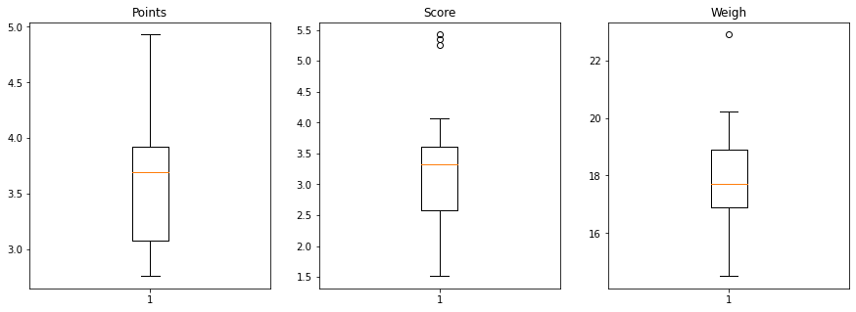
#CODES
import numpy as np
import pandas as pd
import matplotlib.pyplot as plt
import seaborn as sns
%matplotlib inline
cars=pd.read_csv("/content/Q7.csv")
# Mean,median, variance, Standard Deviation for data set
cars.Points.mean()
cars.Points.median()
cars.Points.mode()
cars.Points.var()cars.Points.std()
cars.Score.mean()
cars.Score.median()
cars.Score.mode()
cars.Score.var()
cars.Score.std()
cars.Weigh.mean()
cars.Weigh.median()
cars.Weigh.mode()
cars.Weigh.var()
cars.Weigh.std()
## Range ##
cars.describe()
Points_Range=cars.Points.max()-cars.Points.min()
Points_Range
Score_Range=cars.Score.max()-cars.Score.min()
Score_Range
Weigh_Range=cars.Weigh.max()-cars.Weigh.min()
Weigh_Range
f,ax=plt.subplots(figsize=(15,5))
plt.subplot(1,3,1)
plt.boxplot(cars.Points)
plt.title('Points')
plt.subplot(1,3,2)
plt.boxplot(cars.Score)
plt.title('Score')
plt.subplot(1,3,3)
plt.boxplot(cars.Weigh)
plt.title('Weigh')
plt.show()

Q8) Calculate Expected Value for the problem below
- The weights (X) of patients at a clinic (in pounds), are
108, 110, 123, 134, 135, 145, 167, 187, 199
Assume one of the patients is chosen at random. What is the Expected Value of the Weight of that patient?
Ans: Number of patients = 9
Probability of selecting each patient = 1/9
Therefore,
P(X) = {(1/9*108)+( 1/9*110)+( 1/9*123)+( 1/9*134)+( 1/9*135)+(
1/9*145)+( 1/9*167)+( 1/9*187)+( 1/9*199)}
= (1/9) * (108+110+123+134+135+145+167+187+199)
= (1/9) * (1308)
= 145.33
Hence, The Expected Value of the Weight of that patient is 145.33

Q9) Calculate Skewness, Kurtosis & draw inferences on the following data
Cars speed and distance
Ans: The Skewness and Kurtosis of Speed and Dist is
 | SPEED | DIST
Skewness | -0.1139 | 0.7824
Kurtosis | -0.5771 | 0.2480

The Skewness and Kurtosis of SP and WT
 | SP | WT
Skewness | 1.5814 | -0.6033
Kurtosis | 2.7235 | 0.8194

Q10) Draw inferences about the following boxplot & histogram

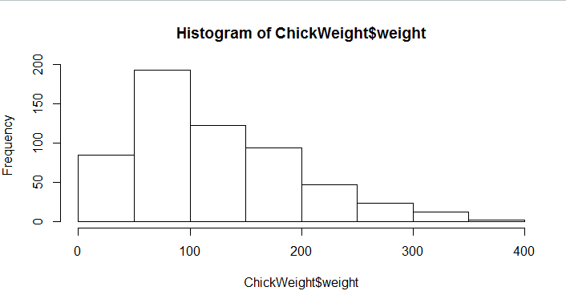
Ans: The most of the data points are concerted in the range 50-100 with frequency 200.
And least range of weight is 400 somewhere around 0-10.
So the expected value the above distribution is 75.
Skewness- we can notice a long tail towards right so it is heavily right skewed.

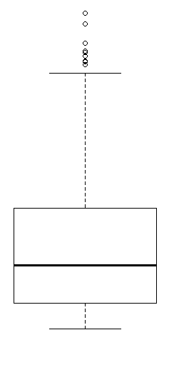

Ans: Median is less than mean right skewed and we have outlier on the upper side of box plot and
there is less data points between Q1 and bottom point.

Q11) Suppose we want to estimate the average weight of an adult male in Mexico. We draw a random sample of 2,000 men from a population of 3,000,000 men and weigh them. We find that the average person in our sample weighs 200 pounds, and the standard deviation of the sample is 30 pounds. Calculate 94%,98%,96% confidence interval?
Ans: Confidence interval is 94%= (198.738325292158, 201.261674707842)
Confidence interval is 98%= (198.43943840429978, 201.56056159570022)
Confidence interval for 96%= (198.62230334813333, 201.37769665186667)
#CODES

import numpy as np
import pandas as pd
from scipy import stats
from scipy.stats import norm

stats.norm.interval(0.94,200,30/(2000**0.5))

stats.norm.interval(0.98,200,30/(2000**0.5))

stats.norm.interval(0.96,200,30/(2000**0.5))

Q12) Below are the scores obtained by a student in tests
34,36,36,38,38,39,39,40,40,41,41,41,41,42,42,45,49,56
- Find mean, median, variance, standard deviation.
- What can we say about the student marks?
Ans: Mean= 41
Median= 40.5
Variance= 25.5294
Standard deviation= 5.0526

Q13) What is the nature of skewness when mean, median of data are equal?
Ans: Symmetrical

Q14) What is the nature of skewness when mean > median ?
Ans: Right skewed

Q15) What is the nature of skewness when median > mean?
Ans: Left Skewed

Q16) What does positive kurtosis value indicates for a data ?
Ans: The data is normally distributed and kurtosis value is 0.
Q17) What does negative kurtosis value indicates for a data?
Ans: The distribution of the data has lighter tails and a flatter peaks than the normal distribution.

Q18) Answer the below questions using the below boxplot visualization.
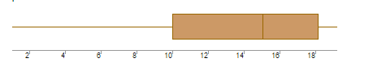
What can we say about the distribution of the data?
Ans: Let’s assume above box plot is about a Hotel timings. 60% of the customers walking is above 10’o clock and Below 3’o clock. And the customers between 3’o clock to 6’o clock is approximately 40%.

What is nature of skewness of the data?
Ans: Left skewed, Median is greater than Mean.

What will be the IQR of the data (approximately)?
Ans: Approximately= -8
Q19) Comment on the below Boxplot visualizations?
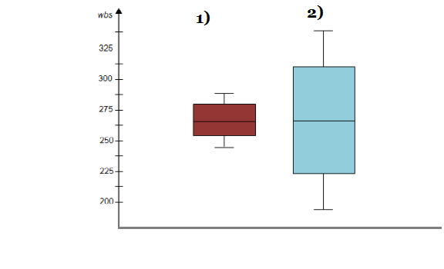
Draw an Inference from the distribution of data for Boxplot 1 with respect Boxplot 2.
Ans: By observing both the plots whisker’s level is high in boxplot 2, mean and median are equal hence distribution is symmetrical.

Q 20) Calculate probability from the given dataset for the below cases
Data _set: Cars.csv
Calculate the probability of MPG of Cars for the below cases
MPG <- Cars$MPG
  - P(MPG>38)
Ans: 0.3475

  - P(MPG<40)
Ans: 0.7293
c. P (20<MPG<50)
Ans: 1.2430

Q 21) Check whether the data follows normal distribution

- Check whether the MPG of Cars follows Normal Distribution
Dataset: Cars.csv
Ans:
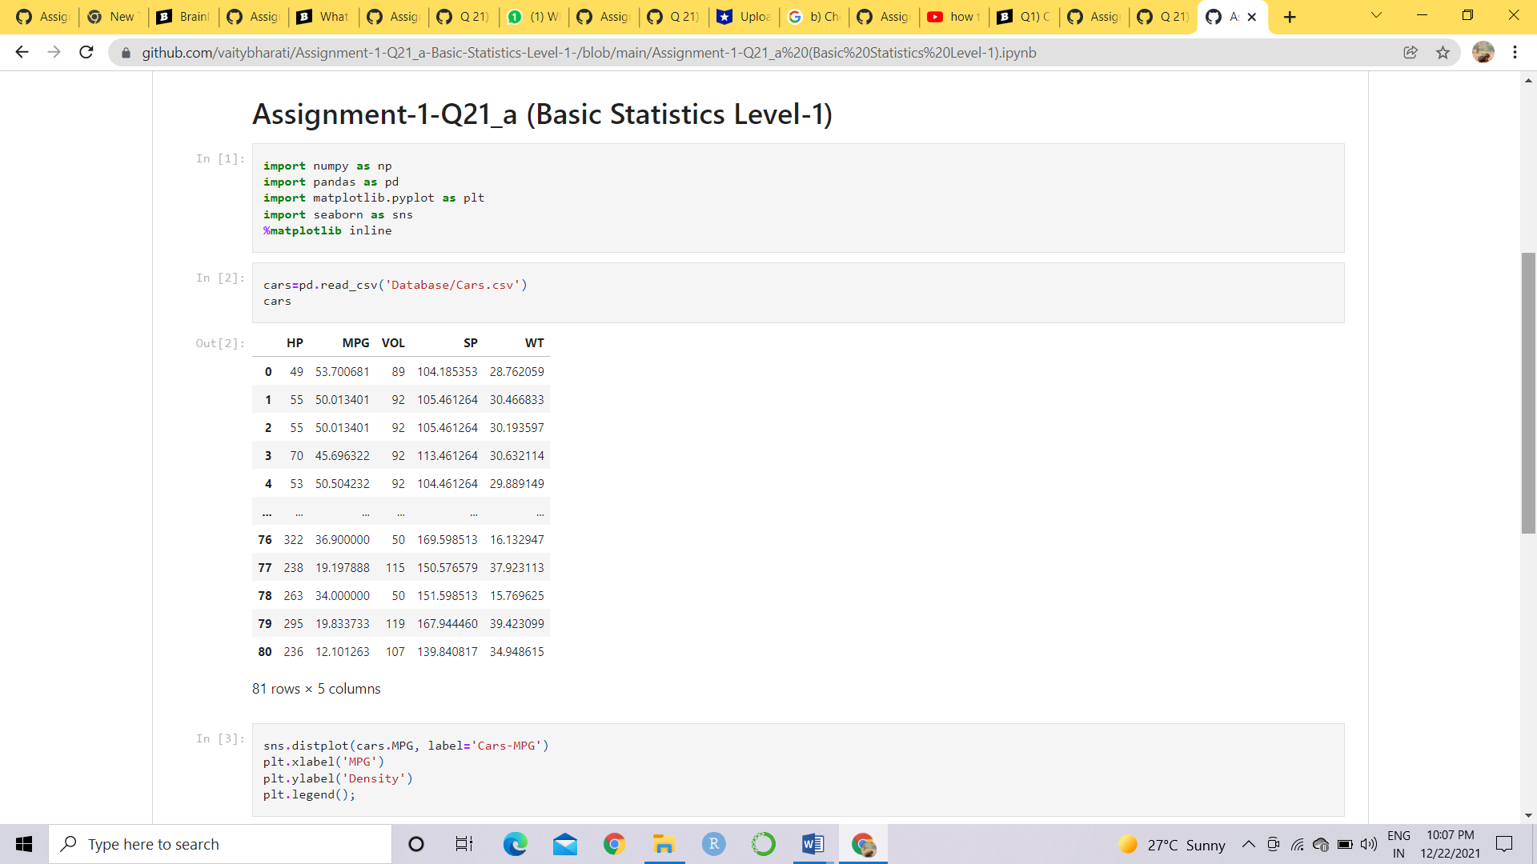

Mean = 34.4220
Median = 35.1527
Mode = 29.6299
Skewness = -0.1779
Kurtosis = -0.6116

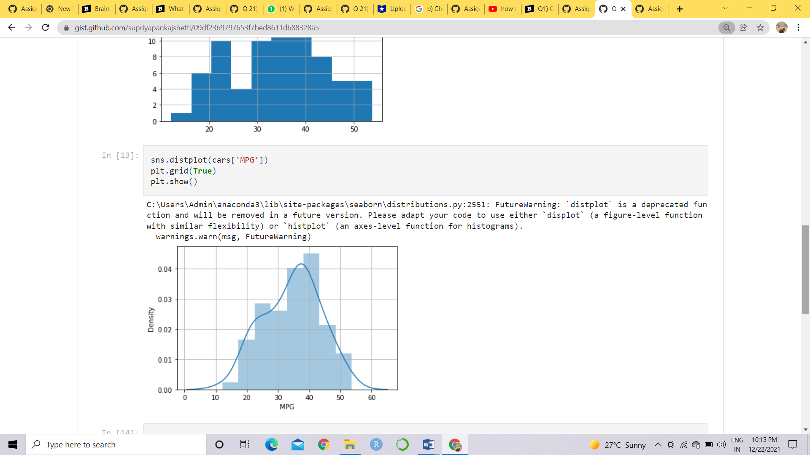
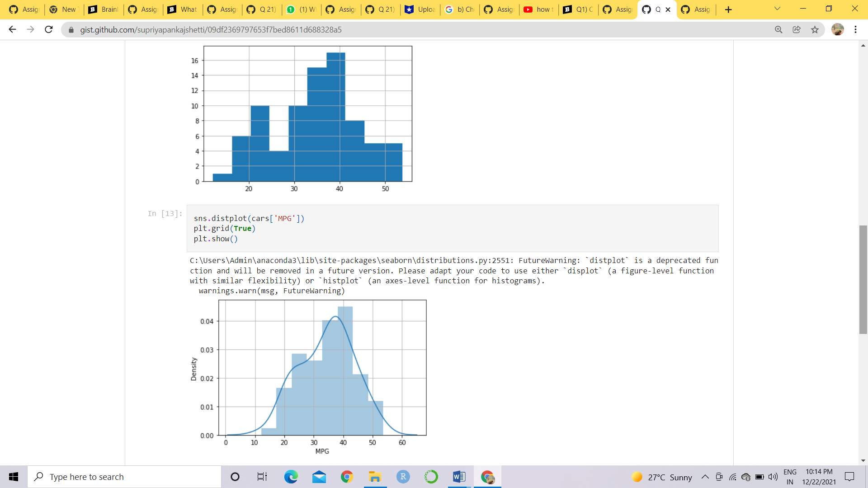

From above plot and values we can say that data is symmetrical and normally distributed.
#Codes

import pandas as pd
from matplotlib import pyplot as plt
import seaborn as sns
cars=pd.read_csv('/cars.csv')
cars
cars['MPG'].mean()
cars['MPG'].median()
cars['MPG'].mode()
cars['MPG'].hist()
sns.distplot(cars['MPG'])
plt.grid(True)
plt.show()
cars['MPG'].skew()
cars['MPG'].kurt()

- Check Whether the Adipose Tissue (AT) and Waist Circumference(Waist) from wc-at data set follows Normal Distribution

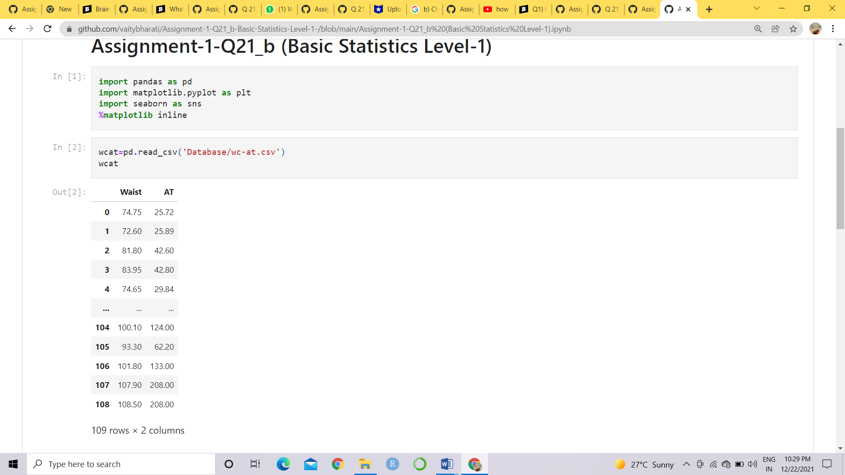

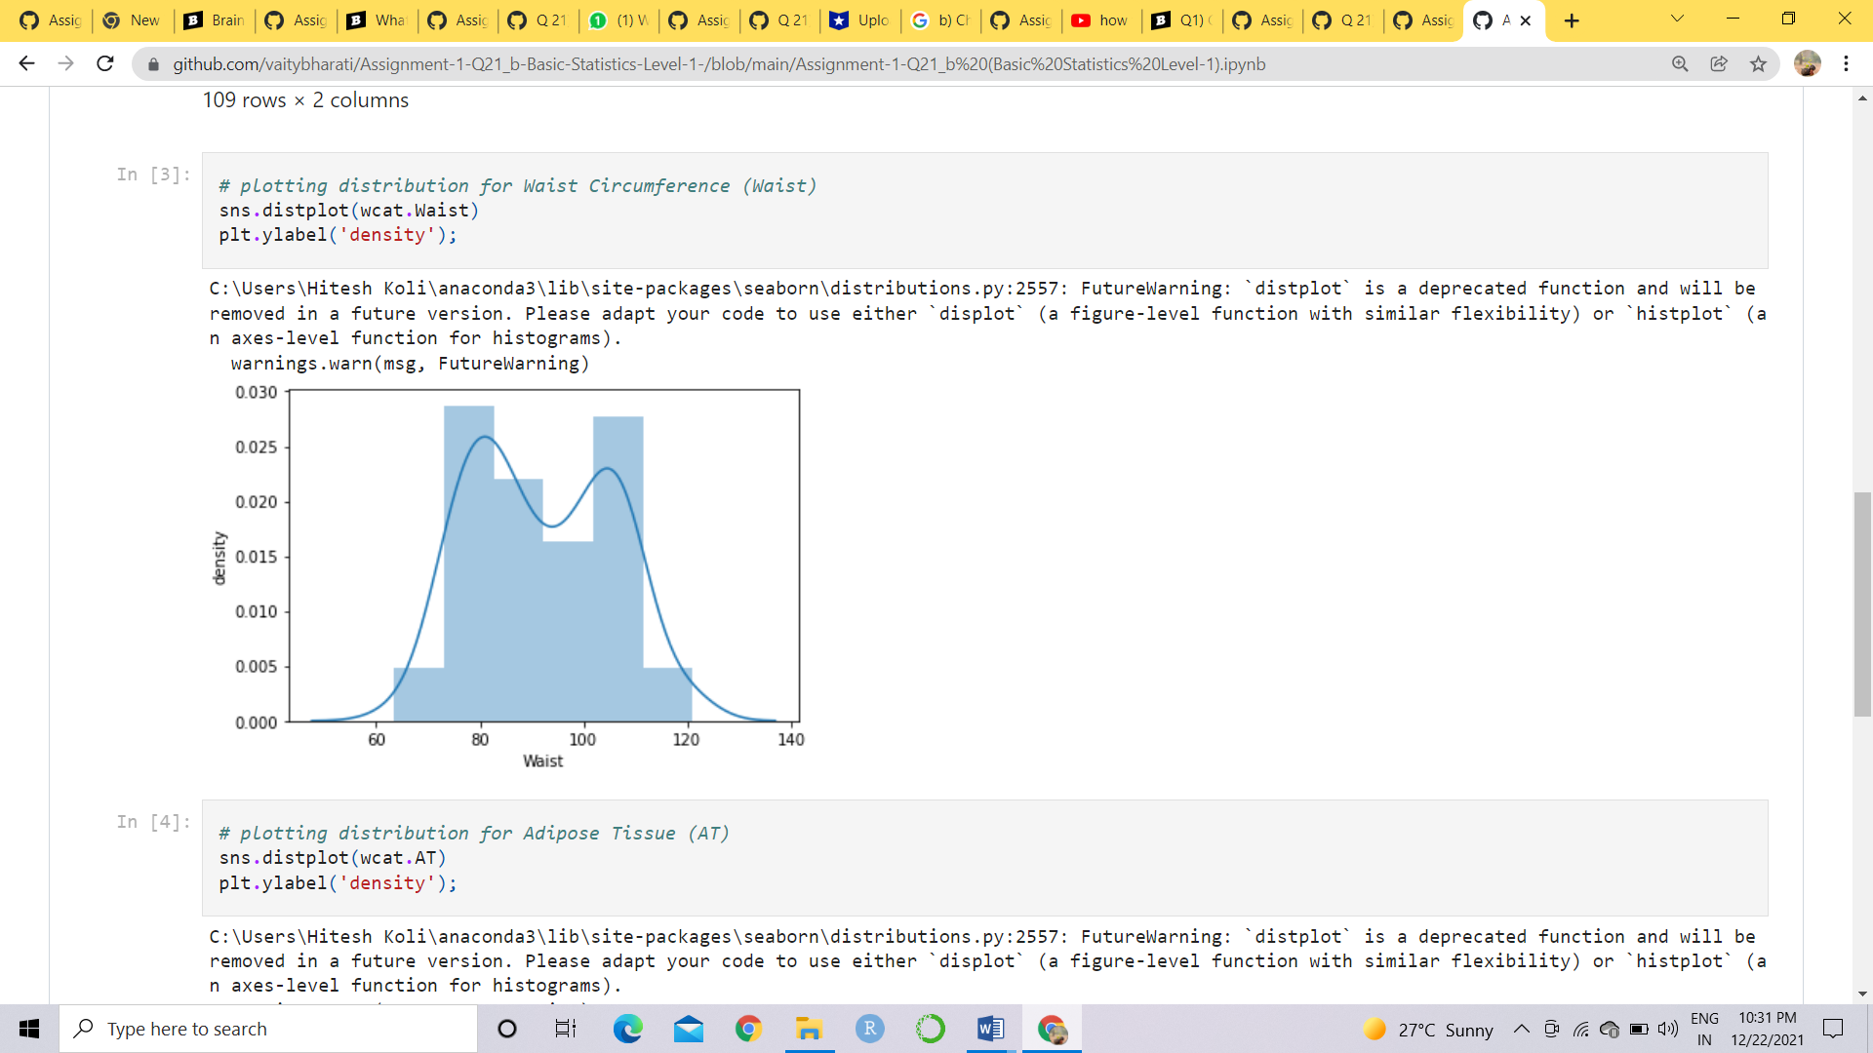
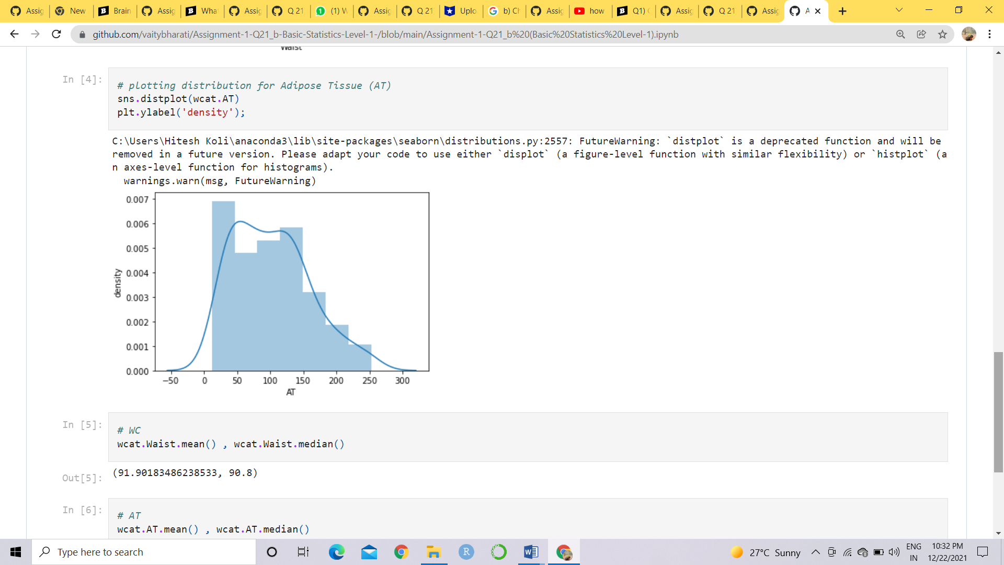

WC MEAN = 91.90183486238533
WC MEDIAN = 90.8
AT MEAN =101.89403669724771
AT MEDIAN = 96.54

From above value and plots we can say that the data normally distributed

Q 22) Calculate the Z scores of 90% confidence interval,94% confidence interval, 60% confidence
interval
Ans: Z score for 90% confidence interval is 1.65
Z score for 94% confidence interval is 1.55
Z score for 60% confidence interval is 0.85

Q 23) Calculate the t scores of 95% confidence interval, 96% confidence interval, 99% confidence
interval for sample size of 25
Ans: The t scores for 95% confidence interval is 1.96
The t scores for 96% confidence interval is 2.5
The t scores for 99% confidence interval is 2.47

Q 24) A Government company claims that an average light bulb lasts 270 days. A researcher randomly selects 18 bulbs for testing. The sampled bulbs last an average of 260 days, with a standard deviation of 90 days. If the CEO's claim were true, what is the probability that 18 randomly selected bulbs would have an average life of no more than 260 days
Ans:
Given,
x = mean of the sample of bulbs = 260
μ = population mean = 270
s = standard deviation of the sample = 90
n = number of items in the sample = 18

WKT: t = x- μ/8/√n

t = 260 – 270/90/√18

t = -10/90/3√2

t = -10/30/√2

t = -1 * √2 / 3

t = -0.471

Probability calculations, the number of degree of freedom is n - 1, so here you need the t-distribution with 17 degrees of freedom.

The probability that t < - 0.471 with 17 degrees of freedom assuming the population mean is true, the t-value is less than the t-value obtained With 17 degrees of freedom and a t score of - 0.471, the probability of the bulbs lasting less than 260 days on average of 0.3218 assuming the mean life of the bulbs is 300 days.

#CODES

from scipy import stats
from scipy.stats import norm

Null Hypothesis is: Ho = Avg life of Bulb >= 260 days
Alternate Hypothesis is: Ha = Avg life of Bulb < 260 days

t-scores at x=260; t=(s_mean-P_mean)/(s_SD/sqrt(n))

t=(260-270)/(90/18**0.5)t
-0.4714045207910317

Find P(X>=260) for null hypothesis
p_value=1-stats.t.cdf(abs(t_scores),df=n-1)... Using cdf function

p_value=1-stats.t.cdf(abs(-0.4714),df=17)
p_value
0.32167411684460556

# OR p_value=stats.t.sf(abs(t_score),df=n-1)... Using sf function

p_value=stats.t.sf(abs(-0.4714),df=17)
p_value
0.32167411684460556

